SPECS: AT A GLANCE
Because one person CAN make a difference.
- Running time: approximately 46 minutes/comp time for commercials

- What IS Transformer? Whilly Bermudez has been changing lives for more than a decade; taking the homeless and giving them a second chance to lead the lives they were meant to live. Changing their appearance, changing their minds, changing their lives….he IS the Transformer.

- Consider that: The National Law Center on Homelessness and Poverty states that approximately 3.5 million people are currently homeless in the United States.

- The intensity of the human experience felt during homelessness, has virtually guaranteed that the catastrophic emotions associated with these events have rendered countless American citizens without homes, money, or hope. Transforming even one individual can have an impact.

- Each show will feature one individual, nominated from one of countless homeless shelters across the United States. This person will be given a total make-over…physically, mentally, and spiritually so that they can get their lives back. Offering a ‘hand up’ instead of a ‘hand out’ the host, Mr. Bermudez brings in a team of local experts to assist with the transformation.

- Think ‘What Not To Wear’ meets ‘Intervention with ‘Biggest Loser?’ and you will have the gritty, raw, often poignant docudrama of a person finding themselves all over again.

Program Format/Concept

The Transformer is a reality based, cross-disciplinary driven docudrama based in the tradition of Intervention, What Not to Wear, and Biggest Loser. Millions of people in the United States suffer the effects of homelessness. These effects leave them broken and hopeless. Now, through the efforts of an exceptional life-changing team using remarkable techniques and insight, these stories of transformation are brought to life like never before. Transformer brings the walking dead back to life. These are their real stories.

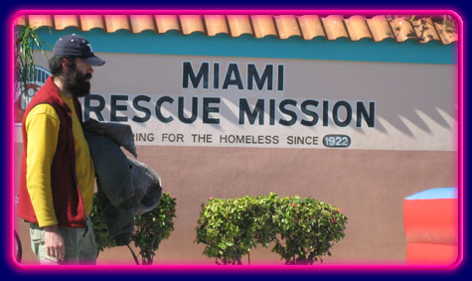

Each week the team will search the hard streets of America’s largest cities for a member of the homeless community. Just over the course of a week, the Transformer team will drastically alter the physical and emotional state of the person. But change is never easy, and the drama that ensues as the transformation occurs is real, raw, and often heart-breaking. The up close and personal behind-the-scenes glimpse will examine the entire selection process from pre-production, production, and post production featuring intimate interviews with the “subject’s” friends / families as well as commentaries from the director and producer. The Show will also make the best efforts to reunite each subject with his/her family.
Synopsis for Pilot
The Transformer: Episode One (Pilot) Somethin’s Gotta Give
- THE TRANSFORMER: OPENING
Street sounds. Montage of ordinary city scenes. Cut to back alleys, homeless centers. Close up on the faces of the homeless. Slam cut to face of desperate homeless man drinking something out of a brown paper bag. A woman rocks her child and tears roll down her face.
VOICEOVER: (while montage plays)
There is a silent battle in the city streets, and each year millions of people lose the fight. It is called homelessness. But it doesn’t have to be this way….
Montage: shots of team interacting with a homeless person, teaser shots of the transformation process, before and after shots.
VOICEOVER: Because in this life, there’s only one shot…..and sometimes somethin’s gotta give.
Hero Shots: The host, Whilly Bermudez
VOICEOVER: He is The Transformer.
- MIAMI, FLORIDA
Whilly Bermudez walking into local homeless shelter to meet with the director of the center.
Director and Bermudez (the host) sit and discuss who Bermudez is and what he hopes to accomplish. The director speaks about the various types of people who use the center. He slides a manila folder across the table to Bermudez and says that he’s found someone that might benefit from a second chance. Bermudez flips through the file, then taking the file, leaves.
- THE TEAM
Bermudez and team meet at Bermudez’s home where they are having a cookout. Here the various personalities of the team can be seen. It is a chance for the team to meet one another and discuss what their roles will be.
At some point they all gather and Bermudez passes the file around. They discuss the possibilities and decide that Jerry is an excellent candidate. But first, and more importantly, they have to see if Jerry is willing to do what it takes to make change happen.
- Jerry
At a local coffee house Bermudez sits having a cup of coffee. Jerry enters the building. We can see that he is scruffy and the look on his face is a mix of fright, anger, and hope. Bermudez motions him over to the table and Jerry sits down. Bermudez tells Jerry what he and his team would like to do for him and why he’s been chosen. He asks Jerry if it is something he wants to do. Jerry tells how he ended up like he did and we find out that because of his homelessness he’s been estranged from his daughter for more than 7 years. He’s been too ashamed to contact her, let alone visit her. He wants his life back. He wants a second chance. Bermudez briefly lays out the process that Jerry will be required to go through. Bermudez ends the segment with the question: So, the question is, Jerry….are you ready to turn this around? Are you ready for some transformation in your life?
Camera CU on Jerry’s face, who is hesitant. The audience is not certain if he will be able to commit to the process. As he’s getting ready to give his answer…..
Commercial break
Return from break shows Jerry and Bermudez shaking hands. Jerry has agreed to give it a try.
- Physical: team member
Jerry enters a gym where the trainer introduces himself. They discuss Jerry’s physical shape and the trainer shows him how he can stay in shape, even if he can’t join a ritzy gym. They discuss things from Jerry’s past, when Jerry was in better physical shape.
As the session ends, the doctor enters the gym and the trainer introduces her as the team doctor. The doctor drives Jerry to her office. Aside from some high blood pressure he is fine. His teeth need some attention, however, and she refers him to a colleague she knows.
- Image experts/Hair and Wardrobe
This is the hair and makeover segment. The image consultants give Jerry a flattering hair style, and assist Jerry in finding 5 good combinations of clothing that will work for both job interviews as well as every day wear. Also, they are wrinkle resistant and will hold up to industrial washers/dryers. They also discuss with Jerry what sort of work he used to do and some more of his background unfolds.
- Dinner with Daryl
Over a meal, Bermudz introduces Jerry to a clinical therapist. He specializes in dealing with homeless individuals. He tells Jerry that one of the most important components of the transformation process is to find that ONE thing that won’t let you quit…even when you’d like to. Jerry talks some more about his little girl. Tears rim his eyes. He has a moment of regression where he doubts his ability to live up to everyone’s expectations. It is critical that they continue to support and encourage Jerry and that Jerry not give up. Will he walk away from the table?
Commercial
- A Job
Camera follows Jerry as he enters an office building downtown.
VOICEOVER: Bermudez and his team have been working behind the scenes to obtain several job interviews for Jerry to attend. With his new look, attitude and wardrobe, they are certain he can land a job. But first, he has to learn how to present himself to the world.
Bermudez will already be in one of the offices, waiting for Jerry to arrive. He is discussing on the phone the fact that last night Jerry almost walked away from the table. He will discuss his strategy for encouraging Jerry to continue. In the room is also a private investigator who will tell Jerry that he is going to be looking for his daughter so that they can be reunited.
Jerry enters the office and Bermudez welcomes him. He tells Jerry that they are going to work on interview skills and how to best present himself. The private investigator is introduced and after obtaining some basic information about the daughter, he leaves.
Jerry is unaware of the intricate nature of the job interview and it is easy to see that the process is frustrating for him. He is out of practice and it is not easy for him. At one point he almost storms out because he can’t seem to get over his nervousness and the overall feeling that he isn’t worth all the bother and fuss. Bermudez talks him through it, but after Jerry leaves he is unsure of how Jerry will actually do on the job interview. He shares that many of their transformation clients bail when it comes to this part of the program. They are just so used to thinking the worst of themselves that it is difficult to think positively. So, the question is…will he show up to the interview, or will he walk?
Commercial
- The Reveal
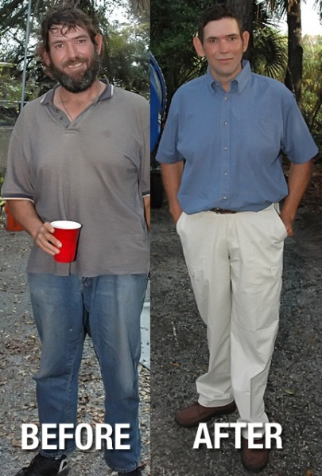
Bermudez’s back yard…another Cookout
The team discusses the transformation process with Jerry. There is a recap and pictures of the process superimposed over their commentaries. Bermudez tells everyone that Jerry had several interviews scheduled for that day. Someone on the team will ask how it went, and Bermudez said that he’d invited Jerry to the cookout, but that he’s late. Some of the team members wonder out loud if they will ever see Jerry again. Others are confident in Jerry’s desire to see his daughter again and to start over.
The gate to the back yard opens and it is Jerry. He is beaming. The transformation is remarkable. As he approaches the group they are all cheering for him. He reaches them and shakes their hands, hugs them. They get him some food. He tells them about the job interviews….he did go…and there was some positive feedback. The team assures him that the assistance will not end when the show is over, that they will still work with him until he is fully on his feet again. In the meantime, Bermudez says he has a surprise for Jerry.
Bermudez opens the door to his house and out steps a young girl of about 15. Jerry’s eyes fill with tears as his little girl comes and gives him a hug. It is a heartfelt reunion and the team responds accordingly. Short interview with both Jerry and his daughter. Jerry says looking at his daughter that it was all worth it and he’d do it all over again. He thanks the team and says that he truly feels like he’s been given a second chance and that he will not waste it. Jerry leaves with his daughter and the team bask in the glow of the moment for a while. Then, Bermudez states that there were a lot more ‘Jerrys’ out there…time to go change more lives. Cause you know what?….one person CAN make a difference.

About the Host
Whilly Bermudez has long been an American marketing entrepreneur and philanthropist, known as the organizer of major advertising campaigns and events in South Florida since 1997. Such campaigns usually involve live events that host celebrities representing hundreds of brands. He is also known as a community leader and is politically active in Miami, Florida. He donates personally to various causes throughout the year, in particularly the Miami Rescue Mission….where he encounters the homeless on a regular basis.
New Times Savy Single Award 2006
Miami Rescue Mission – Honorary Chair / Recipient of the 2009 Life Changer Award
Political Achievements:
2 Time Endorsed by The Miami Herald (2008 & 2010)
United Teachers of Dade (2010)
Miami Dade College (2010)
