About the Author
Wil Smith
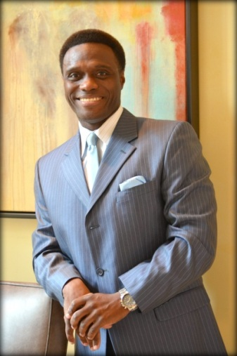
Young urban males now account for over sixty percent of the total U.S. prison population and the number is precariously trending higher. Current estimates indicate that three out of four black males between the ages of 17-26 now have ties to the U.S. legal system. They are either currently in prison, have recently been released from prison, or are on probation as a result of their criminal offenses.

Decoding the Urban Genome: America’s Last Chance to Get Young Urban Males Job-Ready Instead of Crime- Ready, is a provocative new book from sportswriter/urban workforce strategist, Wil Smith; which explores the rising epidemic of crime, and how it has compromised our safety and wreaked havoc on communities all across America. Smith believes that the fallout of a rocky economy coupled with the lack of male leadership in urban homes are the driving factors behind the mayhem.

In his new book, Smith provides empirical data indicating that gainful employment is the only viable solution to the problem, but in order to get them employed, they must first be prevented from getting into trouble, and instead offering credible and meaningful coaching and mentoring to get them job-ready. To bring Decoding the Urban Genome to fruition, Smith invested over seven years of tireless effort generating candid face-to-face feedback from decorated law-enforcement officers, educators, scholars, social workers, business owners, community leaders and other workforce experts.

To combat this cultural pandemic, Smith recently launched Urban Workforce Initiatives, a, jobs-coaching, Christian-influenced outreach initiative, predicated on early intervention while setting up interactive youth work camps, parental workshops, group mentoring/coaching sessions, and job fairs focused on urban employment initiatives. The former Chron.com sportswriter is a graduate of Sam Houston State University, where he earned a degree in sports/media journalism. Smith brings over 20 years of diverse experience in the areas of leadership management, human resources, corporate development, consulting, communications, public relations and workforce development to these endeavors.

Smith partners with churches, schools, colleges/universities and community organizations to assist with urban workforce-related issues and to discuss his inspirational book project. Feel free to contact him at:

wsmith@urbanworkforceinitiatives.org

