Table of Contents

Introduction 2

General Description………………………………………………………………………………..3

Executive Summary 3

Market and Audience 5

Project Deliverables 6

Financial Information 7

Products 9

Company Operations 10

Introduction

Not so long ago you and I were the students sitting in the classrooms across America. And, if you, like me, ever had the thought: “Why am I learning this?” or “What is in this for me?” then you will understand, implicitly, the motivation behind the creation of the Works for Good programs for schools. The Works for Good group was created to tackle the problem of how to act as an intermediary between the business community and the educational process in the schools. For many years, the solution eluded us, until the technology was developed to allow this to happen: Focus on Education.

Our venture is to develop and establish a subscription based online platform that aims to promote health awareness and strengthen learners academically by mobilizing communities’ citizens and leaders to support educational systems through the creating and sharing of video and audio lessons. Each lesson will encompass personal experiences, knowledge, and skills to prepare learners for career specific industries. Our added features are to enrich the learners’ experience through access of other programs gained through the platform in which learners can build and display their own creative expressions through Art, Books, Clothing Design , Film, Magazines, Music, and Newspapers. The largest opportunity of course, comes from the redirecting of time and resources back toward the youth in the schools, so that they see and understand the relevancy of what it is they are learning. Skills learned and reinforced in this program include everything from basic common core components, to social skills and job skills training.

The value of this project has already been recognized by Valdosta State University, whose president has endorsed the program and been instrumental in its implementation into many school districts in the state of Georgia. It is our goal to reach out and to establish more partnerships with other states and additional districts. It would seem that the old maxim: It takes a village to raise a child, has never been truer.

Come be a part of the Works for Good village.

Sincerely,

R. Standifer, CEO Works for Good, Inc .

**General Description and Overview**

The Works for Good program: Focus on Education, has as its core vision the development and strengthening of the educational environment and the community support of the educational systems. Using a technological base to establish these liaisons, Works for Good has as one of its major tenants to produce the next generation of the work force who are dynamic, creative thinkers, able to critically analyze and apply solutions, often before they occur. This is something that is currently lacking from many programs already in use.

In a nutshell, our early projections indicate that an obtainable objective would be to gain an annual user base population of 1,000,000 with a 65% annual growth per year. Our annual targets revenue per year is $850,000.00 at a 20% growth rate.

Our most important company strengths are the ability to strategically partner with local organizations, professionals, and technological expertise to build and train our core operational team until each member can be self-sufficient. This is the key success factor that we will rely on to engage community stakeholders and local decision makers to pilot our eLearning platform.

WorkForGood LLC’s major competitive strengths will be our profit sharing plan per community (PSP). This plan shares and gives 10% of all community sponsorships within the platform funds directly back to all Learning Educational Agencies participating within each community.

Roosevelt Standifer, CEO of WorksForGood has 17 years of personal experience in the educational systems in the United States, and four years working in educational systems outside of the US. Working in multiple communities, he was responsible for engaging key community stakeholders and decision makers to fund local school events to strengthen character development in the lives of local students.

WorksForGood is currently an LLC (Limited Liability Company) and has been in business for several years. With the current climate of educational change sweeping through the nation, and with the focus turning more toward online/virtual learning, Works for Good is poised to take their level of innovation to an entirely new level.

**Mission Statement**

The Works for Good Mission Statement has as its philosophy: Gain to Give, which means as a business we aim to establish ways our business can give back to support each community we reach with our technology programs.

Our organization’s fundamental purpose is to strengthen communities through supporting Education, Local Industries, and Public Health with a technological base platform.

We have as our main purpose to establish a successful company that is a leader in educational and health oriented programming, and is a viable force in developing the next generation of workers.

Company Goals and Objectives:

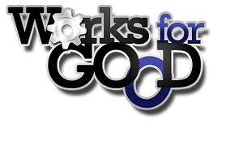

Executive Summary

By harnessing the significant impact that technology has on the learner, Works for Good, will use its highly interactive and progressive self-paced computer program to provide supplementary assistance to classroom teachers and other educational organizations allowing the learner to learn skill sets and academic content, helping them as well as their teachers/mentors to track their progress on the common core standards. Utilizing this pilot program in selected charter schools, Works for Good will show significant gains in reading, math, and comprehension scores on the common core standardized tests, as well as provide students with the knowledge and skills to enter a workforce into an occupation that they have the skills to perform and the interest and motivation to succeed in. The ***Focus Education Program*** is applicable across many platforms and environments, including, but not limited to: workforce development, adult education/GED, public and private schools (K-12), as well as any organization that wants to offer educational opportunities with ties to the local community.

The Objective…

The American educational system has long been at odds when it comes to motivating the reluctant or divergent learner while also meeting the needs of the average and above average student (who may all be included in the same classroom). Additionally, the educator needs to be able to set limits, gauge success and gains, as well as have an easy reporting tool. Students want to learn, but they want it to be ‘fun’. Students want to learn something that they can immediately relate to the real world, and teachers want a viable tool that is easy to use. Skill sets for use in the immediate community are offered to students as an incentive and motivating factor.

* Need #1: Method of improving testing scores and overall comprehension/competency of students.
* Need #2: A program that addresses each student, regardless of level, and allows the teacher a method of delivery that includes the ability to set levels, monitor gains, and report progress on a regular basis with the touch of a button.
* Need #3: Relevant learning environment and subjects with real world tie-ins for all learners, including real world applications, rewards, and benefits.

The Opportunity…

Improvement of test scores, a motivated student body, and an easy to use administrative tool that will allow students in schools utilizing the ***Focus Education Program*** to achieve gains in underserved, hard to reach student demographics (divergent learners, slow learners, level 1-2 students). Additionally, the opportunity exists to allow each student to develop and move as fast as he is able to, encouraging those students that are already excellent students a chance to move ahead rather than being held back by classroom dynamics. A highly educated student body equates across the board to higher achievement well beyond the school years. Additionally, those striving for self-improvement as adult learners ad offered a customized interaction with community stockholders, leaders, industries, and job markets who have specific needs.

* Goal #1: Reach the students where they are academically, socially, emotionally, and physically, and offer them an additional way to learn. Access to learning is made available 24/7 and can be enjoyed from, literally, anywhere in the world.
* Goal #2: Create a learning environment that extends the regular classroom’s potential to reach divergent learners and to give them additional ways to raise academic achievement.
* Goal #3: Bring underserved populations and demographics up to the same level, or above, as those in regular and advanced classes. Students will meet or exceed levels in learning set forth by the state.

The Solution…

First in many things, America lags at an appalling 17th in the world for educational opportunities and achievement. So what are other countries doing that we are not? Individualized educational programs for each student. Our program, ***Focus Education***, will bridge this gap, offering the special attention that each child should be receiving as a matter of course into the ongoing efforts of the classroom teacher. Additionally, it can identify and correct many of the issues that a child is having, problems that up until now may have fallen through the cracks.

* Recommendation #1: Install ***Focus Education*** programs in several Beta Testing Charter Schools. Rising Star Academy located in Gainesville, Florida has agreed to partner.
* Recommendation #2: Educate instructors and administrators about how to implement the new programs. In-service hours could be accrued.
* Recommendation #3: Implement new learning programs in Rising Star Elementary (and others like them).
* Recommendation #4: Follow up with teachers, including on-line help, tutorials, consultations, and quarterly follow up training on-site. Additionally, make the program available on varying platforms for easy access (mobile apps, kindle, PC, etc…)

Summary

The program itself is a virtual reality world where learners can immerse themselves in the virtual world of learning. Students earn learner bucks for accomplishing set tasks and goals (levels determined by teacher) which can be translated into motivating rewards online. Students will be able to ‘live’ and ‘interact’ in this world on a consistent basis, thus creating a ‘safe’ learning environment where it is ‘okay’ to learn and achievement is supported. Embracing the video culture that typifies today’s young learner, Focus Education offers a viable way to level the playing field for those students that have traditionally fallen through the cracks, as well as offer higher achieving students a way to learn more and at a faster pace. If the educator is familiar with Accelerated Reader/Math Programs, or the STAR testing, then some of the same components exist in this program…only as a next generation, highly interactive medium. Following all state standards, this program will fast become the ‘go to’ tool for teachers, and a well-used vehicle by students to raise achievement levels and prepare learners to become productive and active participants in their communities.

Market and Audience

Our primary market is to capture the decision makers responsible for purchasing educational products for a school, after-school center, library, or home school. A secondary market exists in the business and community partnerships within the local community.

According to the research, the worldwide market for self-paced eLearning products and services reached $32.1 billion in 2010 with addition support of a 9.2% compound annual growth rate totaling 49.9 billion by the year 2015. The changes we foresee in the industry, short term and long term are the policies created by each district to adapt to eLearning has significantly increased in the last few years. While the US and Europe are among some of the largest end users of such technology, other countries are quickly gaining ground and most forecasts indicate that within the next 2 years will match what their European cousins are already experiencing. The WorksForGood team will be poised to take advantage of both short and long term changes that has been forecasted in this worldwide market by creating a global sales force with a diversity of cross-cultural products and services.

**Initial Target Audience: Phase One**

In 2012 according to Georgia’s State School Superintendent, Dr. John Barge, a total of 946 middle and high schools in Georgia and 212 charter schools had a total of 981,912 students. Works For Good has Identified 10 Communities and aims to start our pilot programs to assist schools in these geographical areas.

|  |  |  |  |
| --- | --- | --- | --- |
| County | Title | Name | School |
| GLYNN COUNTY | SUPERINTENDENT | Howard Mann | District (Glynn) |
|  | Principal | Matthew Blackstone | Glynn Middle |
|  | Principal | Michele Seals | Jane Macon Middle |
|  | Principal | Jim Pulos | Needwood |
|  | Principal | Senetra Haywood | Risley Early College Academy |
|  | Principal | Toriano Gilbert | Brunswick |
|  | Principal | Glynn Academy | Scott Spence |

|  |  |  |  |
| --- | --- | --- | --- |
| County | Title | Name | School |
| TIFT COUNTY | SUPERINTENDENT | Patrick Atwater | District (Tift) |
|  | Principal | Chad Stone | Eighth Street Middle |
|  | Principal | Jamie Penoncello | J. T. Reddick School |
|  | Principal | James Mark | Sixth Street Academy |
|  | Principal | Scott Haskins | Northeast Campus, Tift County High School |
|  | Principal | Tift County | Dr. Ryan Gravitt |
|  | Principal |  |  |

|  |  |  |  |
| --- | --- | --- | --- |
| County | Title | Name | School |
| THOMASVILLE CITY | SUPERINTENDENT | Sabrina Boykins-Everett | Thomasville District |
|  | Principal | Keith Hose | MacIntyre Park Middle |
|  | Principal | Todd Mobley | Thomasville High |
|  |  |  |  |
|  |  |  |  |
|  |  |  |  |

|  |  |  |  |
| --- | --- | --- | --- |
| County | Title | Name | School |
| WARE COUNTY | SUPERINTENDENT | Joseph Barrow | Ware District |
|  | Principal | Darlene Tanner | Ware County Middle |
|  | Principal | David Hitt | Waycross Middle |
|  | Principal | Ware County High | Tim Dixon |

|  |  |  |  |
| --- | --- | --- | --- |
| County | Title | Name | School |
| DECATUR | SUPERINTENDENT | Fred Rayfield | Decatur District |
|  |  | John Wooden | Bainbridge Middle |
|  |  | Roy Mathews | Hutto Middle |
|  |  | Tommie Howell | Bainbridge High |

|  |  |  |  |
| --- | --- | --- | --- |
| County | Title | Name | School |
| CHATHAM COUNTY | SUPERINTENDENT | Thomas Lockamy | District |
|  |  | James Heater | Bartlett Middle |
|  |  | Kerry Coursey | Coastal Middle |
|  |  | Carol Mobley | DeRenne Middle |
|  |  | Gequetta Jenkins | Hubert Middle |
|  |  | Stascia Hardy | Mercer Middle |
|  |  | Myers Middle | Ericka Washington |
|  |  | Kevin Wall | Oglethorpe Charter School |
|  |  | Kimsherion Reid | Southwest Middle |
|  |  | Troy Brown | West Chatham Middle |
|  |  | Derrick Muhammad | Beach High |
|  |  | Ellis Duncan | Groves High |
|  |  | Danielle Pinkerton | Islands High |
|  |  | Heather Handy | Jenkins High |
|  |  | Bernadette Ball-Oliver | Johnson High |

|  |  |  |  |
| --- | --- | --- | --- |
| County | Title | Name | School |
| Chatham |  | Gifford Lockley | Savannah Arts Academy |
|  |  | Sandra Jenkins | Savannah Gateway to College |
|  |  | Toney Jordan | The School of Liberal Studies at Savannah High |
|  |  | Joe Brasfield | Windsor High |

|  |  |  |  |
| --- | --- | --- | --- |
| County | Title | Name | School |
| LOWNDES COUNTY | SUPERINTENDENT | Wes Taylor | District |
|  |  | Janet Hendley | Hahira Middle |
|  |  | Mickie Fisher | Pine Grove Middle |
|  |  | Derald Jones | Lowndes Middle |
|  |  | Jay Floyd | Lowndes High |
|  |  |  |  |
|  |  |  |  |

|  |  |  |  |
| --- | --- | --- | --- |
| County | Title | Name | School |
| HOUSTON COUNTY | SUPERINTENDENT | Robin Mines | District |
|  |  | Cynthia Randall | Bonaire Middle |
|  |  | Jesse Davis | Feagin Mill Middle |
|  |  | Gwendolyn Taylor | Huntington Middle |
|  |  | Andy Gentry | Mossy Creek Middle |
|  |  | Jan Melnick | Northside Middle |
|  |  | Thomas Moore | Perry Middle |
|  |  | Walter Stephens | Thomson Middle |
|  |  | Brett Wallace | Warner Robins Middle |
|  |  | Ronnie Walker | Watson Center Middle |
|  |  | RonnieWalker | Elberta Open Campus High |
|  |  | Sabrina Phelps | Houston County Career Academy |
|  |  | Michelle Masters | Houston County High |
|  |  | Greg Peavy | Northside High |
|  |  | Darryl Albritton | Perry High |
|  |  | Lionel Brown | Veterans High |
|  |  | Stephen Monday | Warner Robins High |

|  |  |  |  |
| --- | --- | --- | --- |
| County | Title | Name | School |
| PULASKI COUNTY | SUPERINTENDENT | Jane Williams | District |
|  |  | Larry Faulk | Pulaski County Middle School |
|  |  | Rosemary Wright | Hawkinsville High |

|  |  |  |  |
| --- | --- | --- | --- |
| County | Title | Name | School |
| DODGE COUNTY | SUPERINTENDENT | Melinda Dennis | district |
|  |  | Davey Sheffield | Dodge County Middle |
|  |  | Susan Long | Dodge County High |
|  |  |  |  |

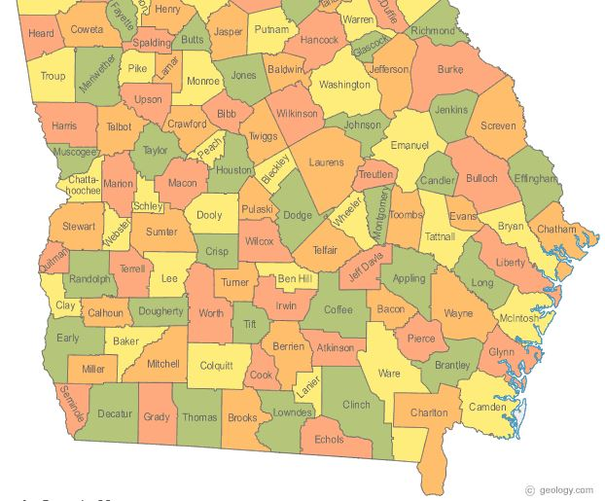

The following describes the target market and audience. The implementation of the marketing is described in the “Marketing Plan” section of the proposal.

The target market niche

WorksforGood LLC has identified a wide range of potential demographics. The initial phase will reach out to school districts as well as universities in the state of Georgia. Valdosta State University has already pledged its support of the program and stands ready to assist in its evolution and implementation.

The size of the target market

There are currently 159 counties in the state of Georgia, with each having its own elementary, middle, and high schools. Many of them have multiple schools in each category. To date, 7 districts have indicated their willingness to implement WorksforGood platforms in their communities.

Project Deliverables

Our proposed products and services are a subscription based learning platform. This platform can be accessed online and offers four ways in which a student may choose to interact: Self-paced learning, Social learning, Collaboration based learning, and Game based learning. According to Ambient Insight’s Learning Technology Research Taxonomy, there are eight key buyer segments in the market. Works For Good will pursue 7 of the 8 buyers segments with exception of Higher Education. Our Strategy is to formalize partnerships between Technical Schools and Universities with The WorksForGood Company for two purposes. First, establish internship plan to create a work readiness job creation program. Secondly, offer a partnership that allows the higher education community to participate in the creating of lessons within our learning platform.

The following is a complete list of all project deliverables as stated.

* Self-Paced Learning  
    
  Learners will be offered the capability to move at their own pace through a series of interactive lessons that they choose. Each lesson comes with its own intrinsic motivator and reward. Students are encouraged to ‘level up’ as it not only increases their knowledge but brings them closer to their self-ascribed goals (learning a usable job skill, interfacing with a real-live mentor in the community, earning ‘learner bucks’, or other).
* Social Learning  
    
  This module and category will be offered for those who are particularly having difficulties with various social issues: peer pressure, anger management, social interactions, etc… It will also feature access to a local therapist who will answer questions posed to them through this venue.
* Collaboration-based Learning  
    
  In this category the learner may interact and collaborate with other end-users to accomplish a goal, complete a task, or solve a problem. Not only does this foster reciprocal learning environments, but it also creates opportunities to learn how to work as a member of a team.
* Game-based Learning  
    
  This category/module consists of ever challenging game sequences that reward the gamer for taking risks, trying new things, and challenging themselves intellectually.

Notes

These modules have flexibility built in so that a user may choose which category they wish to work in at any given time. They are also able to access the program 24/7 from any computer that has an internet connection. Safeties are built in to prevent corruption and fraudulent use by the end users. Additionally, facilitators or instructors are able to tailor each module, or assign them as part of their curriculum as most modules follow the current common core standards.

Product 1: Online Subscription Base Learning

According to Ambient Insight’s Learning Technology Research Taxonomy, there are eight key buyer segments in the market. Works For Good will pursue 7 of the 8 buyers segments with exception of Higher Education. Our Strategy is to formalize partnerships between Technical Schools and Universities with The WorksForGood Company for the two purposes. First, establish internship plan to create a work readiness job creation program. Secondly, develop a partnership that allows the higher education community to participate in the creating of lessons within our learning platform.

**General**

* The World Of Focused Education can be incorporated into lesson plans or students can participate individually and independently.
* The virtual learning platform allows learners to experience real life situations without real life consequences.
* Learners create their own unique avatars and are then placed into the learning world.
  + Additional program details:
    - The learning world begins in the central hub of this 3D environment, His or Her Learning Institution (School or Center). The Administrator will begin by welcoming the learners to this school year and begin giving instruction on how to interact with the platform (how-to-use tutorial). Finally, the Administrator will welcome learners to their teacher.
    - The teacher will give an introduction to the what will be the focus for each session and begin by giving learning assignments to be accessed from the archives of lessons.
    - College students and professionals will be constructing video tutorials on various subjects based on need of the teachers’ demands. (Virtual teaching experience for the colleges can reinforce learning on the collegiate level.)
* Once learning begins, learners will be given a bank account which is located within the virtual community where they will store their virtual, thus reinforcing the concept of “Paid to Learn.”
  + Virtual dollars have to be used in order for the avatar to function in this virtual environment illustrating the cost of living.
  + Each learner can “learn enough money” to purchase:
    - house
    - car
    - clothes
    - food
    - art
    - land
    - farm
    - pets
    - travel to other communities
    - start up own business
    - publish articles/ books
    - gym membership
    - hospital visits
    - games
    - community outreach projects
* Learners will be able to connect their social network to their avatars’ learning accolades and accomplishments.
* In order for learners to stay alive and active in the 3D community, the avatar must continue to demonstrate mastery in skills/subjects, forcing the student to continually go back to their learning institution to earn more virtual dollars to “Afford the Cost of Living.”
* Parents will have access to monitor progress in addition to having access to audio/ video/email with in this platform to connect directly to students’ teacher and counselors for added support if they choose.
  + Parents will also have opportunity to explore the 3D world and learn for themselves.
* Learners will have options to explore based on level of interest:
  + Community Builders
  + Enterprise Explores
  + Health Advocates
  + Art Enthusiast
  + Music/Film Pioneers
  + Clothing Designers
  + TV Supporters

**Personal Skill Development**

* Through positive and negative reinforcement in real-life situations, students learn about healthy personal habits such as nutrition and exercise, and receive positive reinforcement to practice healthful habits. They are rewarded for maintaining good habits/making wise choices, and have “virtual consequences” (e.g., loss of reward, relationships, or resources) for making unwise choices.
* Students learn about other cultures by virtually traveling to other communities. As they participate in a different culture, they learn new languages, customs, traditions, and even laws.
* The actual virtual learning dollars can be spent within this 3D virtual community to teach learners:
  + Cost of living realities
  + Positive decision-making skills
* The World of Focused Education integrates a Drug Awareness Program - An opportunity for learners to be educated about drug abuse prevention. Again, wise choices result in rewards; unwise choices result in virtual consequences.

**Community Leadership Development**

* The World of Focused Education provides *real-life* opportunities to serve - real ways kids can plug into their own communities and local volunteer opportunities .The World Of Focused Education teaches students how to become community leaders and develop social awareness by caring for those around them.
  + Each community will have an assessment performed to highlight local issues within communities.
  + Students may join community awareness programs in their community
* Students may confront and deal with social issues challenging communities via chat rooms where kids can propose positive action plans (e.g., obesity, pregnancy, bullying, student drop-out, hunger, poverty)

**Workforce Skill Development**

* Industrial leaders will be able to influence the next generation of learners to help them fit the roles that will be available in their respective industries:
  + Mentorship/Entrepreneurship: Videos interspersed in the virtual learning community will provide input from mentors and entrepreneurs to inspire and encourage them, and provide them with knowledge about different business and industry sectors.
* Opportunities will be presented for students to create their own virtual businesses and learn skills sets necessary to be successful entrepreneurs
* Opportunities for hands-on experience:
  + Kids can participate in real (not virtual) hands-on experiences such as music production, which will be played on the virtual radio.
  + Movie industry executives will also provide the opportunity for learners to develop their own movie-making skills and display their productions within the virtual learning community.
  + Aspiring authors may also write their own articles, short stories, or books, and present their creations in the virtual learning world
* Learn from real-life academic experiences
  + Leaders in the current workforce participate to share their stories of what they learned in school that has help prepare them for a career in their particular industry. In addition, learners will also impart what they could have learned differently to help better prepare them for a career in that particular industry.
  + Learners can become a member on a collaborative group that provides opportunities to work on special hands on projects that each company might want to establish within their community.

The Workforce Development component of The World of Focused Education aims to create a powerful database created by local industry leaders, which allows students to align their interests and the things they value in their work environment (e.g., working with people, working outdoors, etc.) with real careers. This engine will be the niche separating Works For Good LLC, and other Elearning companies. Our desire for every community is as students’ progress and advance in learning, they will receive guidance about careers that might be a good fit for them for local industry experts. They will also receive a “career map,” which outlines the path from where they are now educationally/skill-wise, to where they need to be to begin the career of their dreams. Also, as a part of The World Of Focused Education, students will have opportunities to develop skills and knowledge in the areas of their career interests. Lastly, students will learn about the current and future availability of suitable careers in their local area.

**Buyers: 7 of 8 segments.**

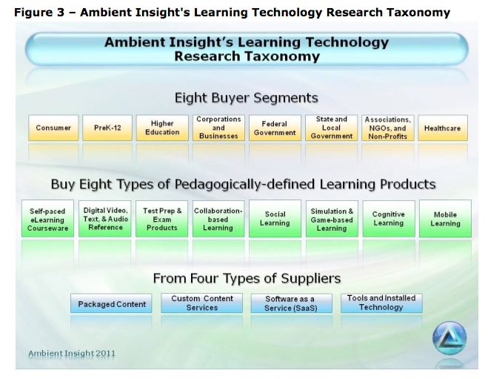

**Users:**

1. Middle & High School Students will enter the platform for learning and creating.
2. Social Network Patrons will enter the platform to view and support the highlights of individual users learning milestones or creations within platform.
3. Teachers will enter the platform for instructing, creating lessons, or monitoring students.
4. Community Leader will enter the platform to create lessons.
5. Counselors will enter the platform to answer questions or concerns of students or parents.
6. Parents will enter the platform for monitoring and learning.
7. Administrators will enter the platform to retrieve data of schools learning progress-

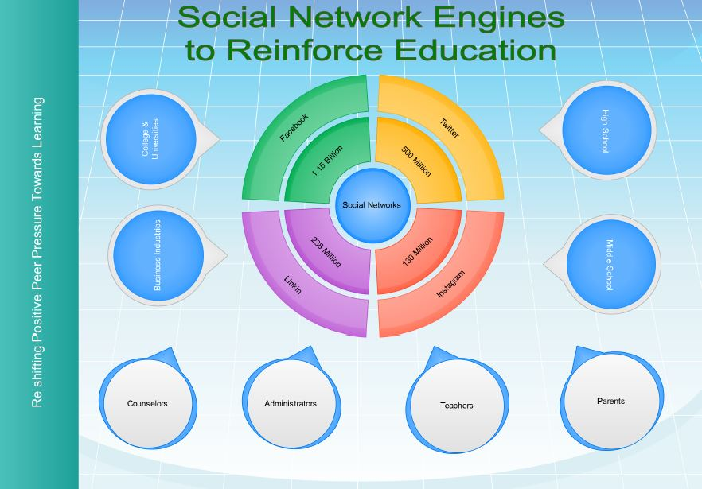

**New Products Developed by the Students in Platform:**

Features with Platform , Students will have the ability to create books, magazine articles, newspapers articles, or poetry that will be published and distributed by WorksForGood.

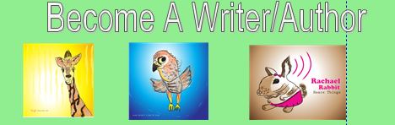

O

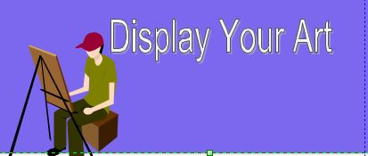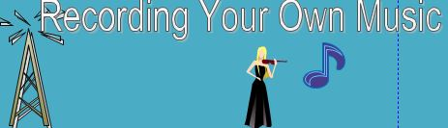

Financial Information

Following is a summary of Works for Good Foundation’s financial information.

Federal Tax Id:

The following are projections for profit based on current programs of a similar nature and their implementation into similar environments. Data based on annual statements for Accelerated Learning Programs and STAR, as well as FCAT Explorer. The implemented pricing per student is $3.00, which could be included as part of a materials fee, matriculation fee, or as part of the purchased planner fee that most students are required to purchase at the beginning of each school year. For those students who are on free or reduced lunch, accommodations could be arranged with each school (based on their individual provisions and policies).

SUMMARY:

When one looks at the figures, it becomes evident that not only is Works for Good poised to break even by the second year, but in consecutive years will meet and exceed initial investments by significant percentages. Incentives could exist for those investing in the company for multiple years.

Projections

Years 1

Sales Forecast

The following chart shows the first year’s cash balance and cash flow. The table shows the expected cash flow for the first twelve months of operation. Capital expenditures include computer equipment and technology & software investment, as well as office space:



Projections

Years 2-5

Sales Forecast

SUMMARY:

By years two-5 WFG will have significant data and figures proving that the system and the program are inherent to the success of the students in school. This data will include information and figures obtained from the school system based on standardized testing scores, level of interaction within the community, and life-skills acquired by the students. This data generated will enable WFG to market to the additional school districts who were not originally part of the initial beta test. Year two we hope to add more districts to the WFG group. A breakdown of the revenue potential per student, per district is included below. Assumptions are that the cost per student to utilize the system is only 3$ per student.

|  |
| --- |
| County/Georgia |
| GLYNN COUNTY |
|  |
| TIFT COUNTY |
|  |
| THOMASVILLE CITY |
|  |
| WARE COUNTY |
|  |
| DECATUR COUNTY |
|  |
| CHATHAM COUNTY |
|  |
| LOWNDES COUNTY |
|  |
| HOUSTON COUNTY |
|  |
| PULASKI COUNTY |
|  |
| DODGE COUNTY |
|  |

|  |  |  |  |
| --- | --- | --- | --- |
| Student Population | Revenue/yearly | | |
| 7016 | 21048 | | |
|  |
| 4045 | 12135 |
|  |
| 1536 | 4608 | |
|  |
| 3125 | 13824 | | | |
|  |
| 2901 | 8703 | | | | | | |
|  |
| 18206 | 54618 | | | | | |
|  |
| 5772 | 17316 | | | | | | | |
|  |
| 15807 | 47421 | | | | |
|  |
| 752 | 2256 | | | | | |
|  |
| 1765 | 5295 | | | | | | | | |

|  |  |
| --- | --- |
| Average cost per system | 18,722.0 |
| Total Cost for 10 systems | 187224.00 |
|  |  |
| Total Revenue (10 systems) Year Two | 3100550.00 |
|  |  |
| Realized Gross Profit: | 2728326.00 |
|  |  |
|  |  |

Summary: WFG has as its Phase Two operations to expand into surrounding southern states. Based on preliminary numbers the realized figures are below:

|  |
| --- |
| **Georgia** |
| **Florida** |
| **Alabama** |
| **Tennessee** |
| **South Carolina** |
| **North Carolina** |

Total Revenue (years 3-5): 15,146,854.60

With this model, the revenue will substantially come from interested districts as well as private end users. Students who do not have a participating school district are still able to access and participate on a private membership basis.



Figures based on similar programs and implementation. Expenses include overhead for buildings, personnel, technology, and implementation. These figures are based on conservative number of 7 districts added per year and will include the states of Georgia, Florida, and Alabama.

Company Operations

The following is a description of Works for Good Foundation’s operations.

The items outlined below cover the basics of company operations dealing with people internally and externally and business processes internally and externally now and in the future.

