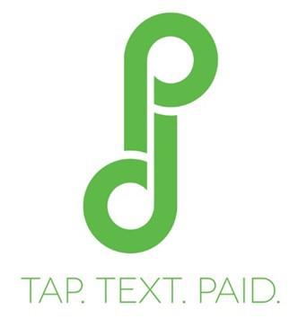PAY2DAY
A New Year with New Expectations…..

Pay2Day Investors Newsletter Quarter One 2015

As 2014 draws to a close, I am pleased to send this first of what will now become a quarterly shareholder update.

You will be happy to know that I am more convinced than ever that we are on to something significant. The billing and payments industry is incredibly fragmented and in desperate need of technology. This translates into opportunity for Pay2Day. It would be remiss of me to not mention Apple Pay, as I have likely spoken to each of you regarding the launch this year of Apple’s new payment initiative. Keep in mind that long before Apple Pay, there was Google wallet, ISIS mobile, PayPal, and every credit card and bank in the industry attempting to create an “APP” to own the consumers digital wallet. This is a Trillion dollar battle and Pay2Day is benefitting from all of the coverage.

Apple Pay is no panacea to the industry. It is interesting, convenient, but in the end it does not change the way payments are made, is far from ubiquitous and controls the one thing that all retailers want - data. So, yes it will be successful but in my humble view Apple will find that payments is not music and will struggle to find partners and adoption. In the end retailers want to own the relationship with consumers, and consumers do not yet completely trust placing personal data on a
device (even if that is only perception). Regardless, all of the media has lead many of our partners to be much more interested and aggressive in their efforts to devel- op cutting edge payment solutions as a way to maintain their relationships and market share. Enough said…all payment news is good news.

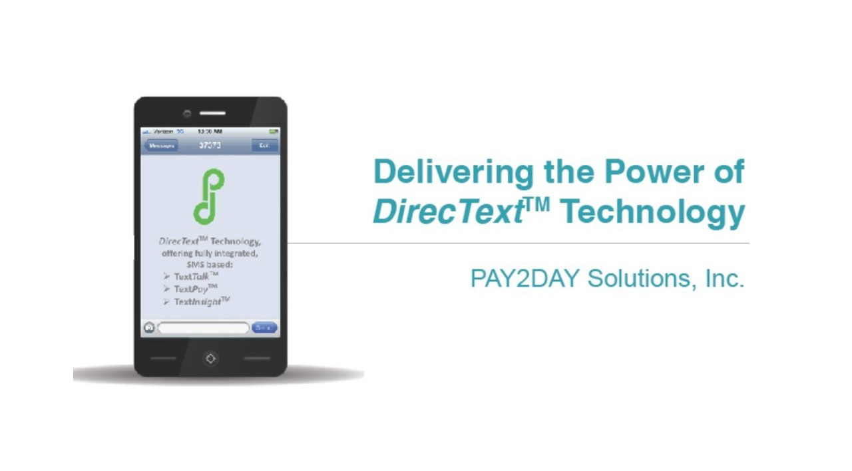Looking ahead, we plan to maintain an aggressive customer acquisition plan and technology development program, adding incremental staff overhead only as nec- essary. Furthermore, as we gain experience with the nuances associated with various vertical markets, we intend to produce more precisely targeted sales & marketing programs to ensure adoption rates are maximized for each environ- ment. In summary, our overarching goals are to maintain product development momentum, gain additional market traction through customer acceptance, gener- ate revenue from operations, and continue building a team that supports these initiatives.

A simple and secure, enterprise-class messaging platform
In This Issue
- Pay2Day High- lights
- Pay2Day Product(s)
- Beta Testing Re- sults
- Expectations

Chris Brunner, CEO
“Initially, I expected the 20-30 age group to sign up for the mobile program, but we had customers well into their 50s and 60s signing up as well. It has been very well received by our customers. At Pulaski, we provide every avenue possible for the customer to take care of business, with 15 percent of customers accepting bill notifications via the web and 10 percent of them paying online.
We anticipate similar results through the text program.”
- Daryl Williamson, VP of Cus- tomer Support , Pulaski Electric Systems

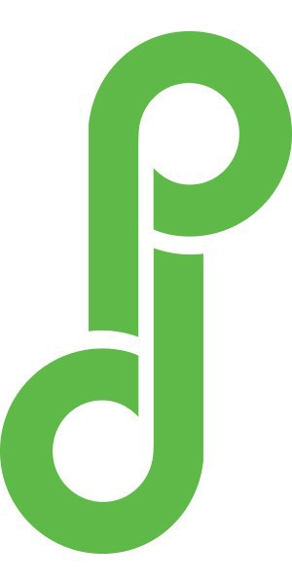Your Pay2Day Product
Secure mobile electronic bill presentment and payment in a effortless text messaging presentation that consumers are already using everyday.
Line
TextTalk*TextPay*Text Analytics

All products have undergone early testing and focus groups are rav- ing! Certain necessary delays oc- curred so as to integrate increased cybersecurity efforts. Our R&D have made the following improve- ments:

  - Bill upload - so billers can upload of database of 100k names or more into the Pay2Day engine.

The News is Good
Pay2Day Solutions has hit the ground running and is continuing to gain momentum in the new year. Between May and October of this year we managed to secure
$1.1mm in funding at a $5.7mm valuation. We have pulled together an interesting mix of strategic investors. And, we are well positioned for our next round should we need to raise additional capital, as it is likely we would not need to go the traditional VC route.

One of our greatest accomplishments was the addition of Paytek Solutions as our launch partner. Paytek is a mid-tier aggregator that had deep industry relationships and has truly been an amazing launch partner. They have advised us each step of the way, they continue to make incredible introductions, and in fact, they will be li- censing the very platform that we have built. A win - win for all of us.

Joining Paytek in the Pay2Day endeavor is Avatas Payments, who are set to be our second launch partner. We will be meeting with their team in Boston in January. We have had product, technology and partner discussions with them. Their CEO invest- ed in Pay2Day and is a big fan of the companies.

We have recently purchased Avatas Payments who process $4b in payments annu- ally, adding to our operating revenue significantly and adding an additional layer of protection for all investors.

Joining the Pay2Day Family

There are another 4-5 major companies that we have lined up and ready to go. Each of the companies above represent hundreds if not thousands of billing relationships with utilities, auto finance, student loans, school districts, consumer loans, etc. In effect, if we did nothing but execute on the first 4 companies that we have agree- ments with, we would have a universe of tens of millions of bills monthly.

It is expected that our first LIVE (Paying) customer will launch end of January and that should be Roanoke, Tennessee. Right behind them in February we expect Tem- pe, Az to go live. A college town of 300k we expect to have some very interesting results with this partner.
- E-bill Pay- A full electronic web based payment interface (Ui/UX)

- Recurring Payments (the ability for a consumer to set up a recurring pay- ment via web/sms payment

- ACH/CC/ - Ebill and Text based

- Token X - Top of the line security implementation

The Future Has Arrived

